# GRADING CRITERIA

### • Synopsis (150-250 words)

– Creativity

– Establishment of conflict

– Fitting to theme

### • Character Traits & Temperaments

– Character line up

– Character profile

– Distinct difference between characters

### • Dialogue

– At least 15 lines of dialogue for each character

– Consistency between character traits and dialogue

# Topic 1

Theme of story: my crumbling self pity of a mental health in the form of an island

Conflict: protagonist wants to save the island, antagonist wants to destroy it

Antagonist plot: a realistic person that recognises there is no hope in saving the island, so they want to put it out of its misery faster

Protagonist plot: a hopeful (and a bit aloof) person that wants to hold out until a prince saves the princess situation happens

Protagonist sidekick: optimism, humor (any extroverted personalities)

Antagonist sidekick: negativity, anxiety

Neutral (or can change sides): judgment, humor (betrayal arc)

# Topic 2

Make a story based on embryo

Red vs blue

# **Character Traits**

## Fire god:

is a sad and bitter guy that got killed by father just for being born. Probably make him be younger and rash. Has explosive temper, acts childishly, guy that brute forces when possible

### physiological

* Sex: male
* Age: 27
* Physique: big and poised body, has lean muscles
* Facial features and hair: has blue hair and baby face that always has a cold and stern look.
* Colour of attire: blue and white
* Posture: poised

### Sociological

* Occupation: general?
* education: erm wha
* Reputation: respected warrior
* Friends: idk honestly

Thunder god: (technically) child of fire god that has a lot of notable achievements. The cool and composed guy. Tolerant, but very scary especially when mad. The responsible older man with a sense of duty

A reflective narrative essay consists of a beginning, middle, and ending. The beginning, or introduction, provides background and introduces the topic. The middle paragraphs provide details and events leading up to the change. Finally, the ending, or conclusion, sums up the writer's reflection about the change.

Introduction: background + topic introduction

Mid Point: details + events leading up to change

Ending: summary of reflection about the change

# 

# 

# The story

## Introduction to characters and context

Distant rumbles and crashing waves as the pieces of the island crumbled and tumbled into the ocean. Elder trees leaned heavily to their sides, their bodies threatening to give out and snap at any moment. Rain and wind descend mercilessly upon the land, tearing young saplings up from the soil, leaving the now naked ground where they once stood to brave the elements alone.

Amidst the howling winds and pelting rain stood 2 battered people in a tense standoff, unwavered by the sheer chaos surrounding them. Time slowly trickled by, every second crucial to determine the outcome of the very island they now stood on. To crumble and dissolve into vast ocean around them, or overcome another disastrous weather once more. To sink into the endless depths beneath the waters or live to witness the development of this budding land filled with precious lives into a mature, self sustaining land. This very encounter can change the legacy of this sacred island…

# References

## - story structures

<https://blog.reedsy.com/guide/story-structure/>

## - audio visualizer

[Specterr_720p_audio.mp4](https://drive.google.com/file/d/1WS2qWpFs_gWBs5zKnU4O2Fp37_-hgvDZ/view?usp=drive_link)

## - embryo wiki

<https://remywiki.com/Embryo>

-> “ΣmbryØ represents Takemikazuchi no O no Kami (建御雷之男神) and Hi no Kagutsuchi no Kami (火之迦具土神)”

### -> Kagutsuchi (fire god)

<https://en.wikipedia.org/wiki/Kagu-tsuchi>

#### background

> Is fire god whose birth killed his mother

> was killed by his father out of grief over his mother’s death

> beheaded and cut into 8 pieces

> pieces of his corpse became volcanoes and created deities

> one of 8 deities created from his corpse is Takemikazuchi

> his father that killed him, is the god of creation

### -> Takemikazuchi (thunder [and sword] god)

<https://en.wikipedia.org/wiki/Takemikazuchi>

#### Background

> was created when the god of creation killed the fire god over the loss of his wife due to childbirth

> fire god’s blood that dripped from the sword used to kill him fell to the ground and created 8 deities, one of which is Takemikazuchi

> is created out of blood that flowed near the base of the sword that killed fire god

### -> image

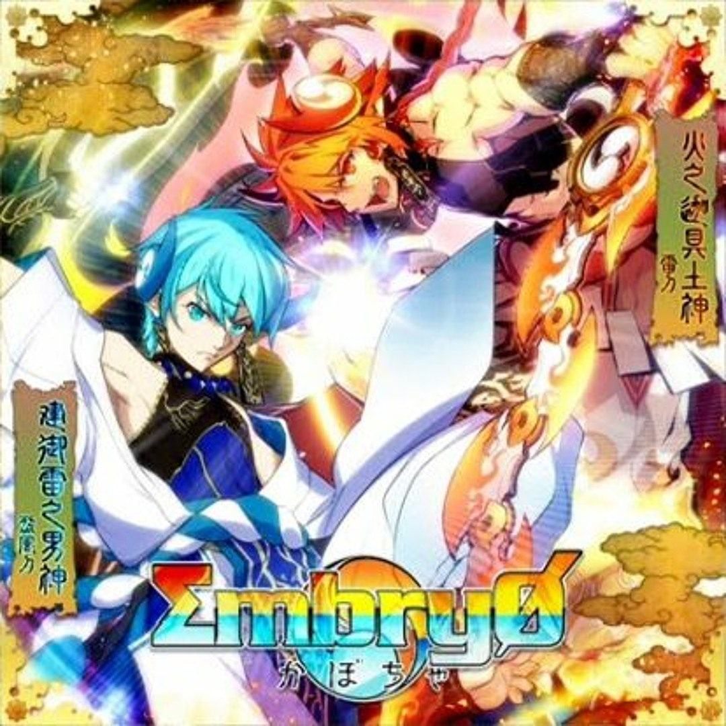

### -> gameplay video

[[SDVX] ΣmbryØ [MXM] PUC](https://www.youtube.com/watch?v=jIMl7oNaon4)

# Anyhow writing story

## Initial conflict

Central problem: protagonist has to work with antagonist to protect the island

Stakes: island will be destroyed

Plot: conflict causes weather over the island to worsen as their argument over what is best for the island becomes more hearted

Protagonist’s goal: to protect the island and pass the day

Protagonist contradicting value with antagonist: prioritizing personal enjoyment

## Rising action

Main foreshadowing: surely procrastinating wouldn’t cause issues right? ‘ –‘

## Climax

## resolution

